**©Kantar Media is pleased to announce the release of Reach Analysis in MARS MEDICAL ONLINE (MMOL).**

*If you are currently not licensed for **Website or Readership Analysis** data and are interested please

contact your account manager.

***What is Reach Analysis?***

This module will allow MMOL users who subscribe to any of our Website Usage and Readership studies to analyze **by specialty** the **total audience potential (reach)** of a multi-platform advertising schedule.

The Reach Analysis module will allow users to pick their media properties and enter the number of monthly buys with associated costs, and the system will calculate reach based on readers/users for the media on the entered schedule.

***5 easy steps to generate a Reach Analysis report***

1. Open or create a project
2. Select your Target Audience
3. Select your Media (Journal and/or Online)
4. Enter number of buys (insertions ) and cost per insertions
5. Generate your report

Step 1 – Open or create a Project

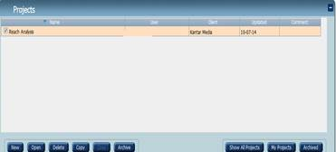

**Step 2 – Select your Target Audience**

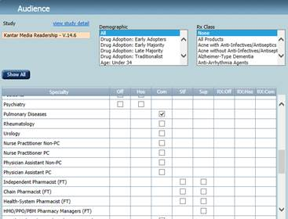

**Step 3 - Select Media Group, Media and Formats (J=print OI= website)**

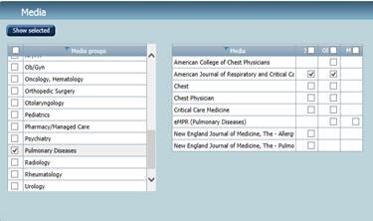

**Step 4 – Go to Parameters; Select Reach Analysis and enter number of Print buys (insertion total per title) and the average cost per print buy. If applicable, enter number of Web buys (how many months will the ad run on the website).**

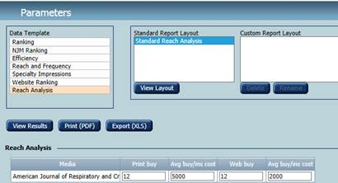

**Step 5 – Generate report by selecting the Export (XLS) button to run the report. Below is a sample of report with annotations**

